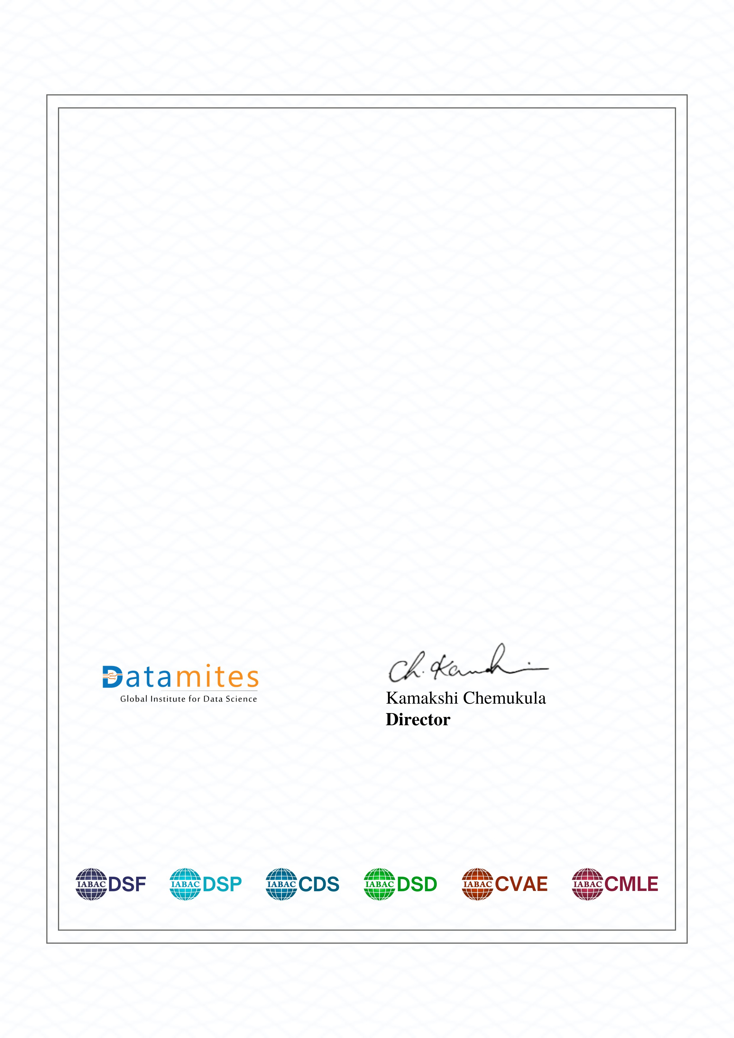

**Certificate of Completion**

*This is to certify that*

**Misriya M.S**

*has completed the course*

**CERTIFIED DATA SCIENTIST CERTIFICATION TRAINING**

Attended on dates : 22nd Jul , 2024- 28th march, 2025

120

Hours Training

**Certificate No: 97250425095825**

*Accredited by reputed Certification Bodies across the globe*

[Powered by TCPDF (www.tcpdf.org](http://www.tcpdf.org/)

[)](http://www.tcpdf.org/)